**SHANNON GOLF CLUB – ALL IRELAND CHAMPIONS 2022**

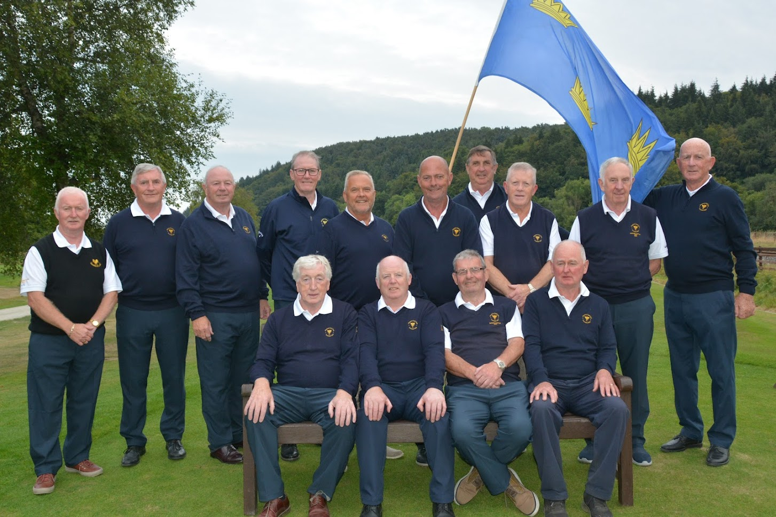

| **Placing** | **Golf Club** | **Province** |
| --- | --- | --- |
| Winner | Shannon Golf Club | Munster |
| Runner Up | Royal Curragh Golf Club | Leinster |
| 3rd Place | Dunmurry Golf Club | Ulster |
| 4th Place | Castlebar Golf Club | Connacht |

**2022 ALL IRELAND FINALS 2-4 SEPTEMBER 2022.**

**Friday 2nd September 2022:- The opening ceremony was held, our resident piper Denis New led a parade to the Clubhouse and welcomed the four 2022 finalists with a tune from each province.**

The four qualifying teams were Munster - Shannon GC (Clare), Connacht - Castlebar GC (Mayo) Leinster Royal Curragh GC (Kildare) .  Ulster - Dunmurry GC (Antrim)

**President Lesley Williams outlined the history of the J B Carr Diamond Trophy Tournament and welcomed the four Provincial finalists to Woodenbridge Golf Club for a weekend of good golf and new friendships.**

**It was the 25th All Ireland Finals Competition and great to welcome the clubs after an absence of 2 years due to covid-19 restrictions.**

**Mr Henry Crummy conducted the draw for semi-finals. A drinks and canapés Reception was then held in the Clubhouse.**

**Saturday 3rd September 2022:- Conditions were extremely wet all day which led to challenging conditions for the semi-final matches.**

**Results Saturday 3rd September 2022:-**

**Shannon 3 Castlebar 2**

**Royal Curragh 3 Dunmurry 2**

**Sunday 4th September 2022:-** It was a relief to see the sun shining and the teams enjoyed a dry and sunny day. A very exciting finish to the  2022 J B Carr Diamond Trophy  All Ireland Finals.

3rd & 4th Playoff at 10 am  Dunmurry GC played Castlebar GC -  Dunmurry came out ahead securing 3rd place.

The All Ireland Final at 11.am featured Shannon GC vs Castlebar GC -  with Shannon Golf Club (Clare ) Munster the 2022 J B Carr Diamond Trophy Champions. A great match played with sporting spirit.

A great days golf in Woodenbridge today.

**RESULTS**

**10 am Dunmurry 3 Castlebar GC  2**

**11am Shannon 3 Royal Curragh 2**

A Gala Dinner and Presentation of Prizes took place in the in clubhouse at 7 pm on Sunday evening. We were honoured to have John Carr, Son of the Late J.B.Carr and Mary Carr wife of the Late J.B.Carr in attendance to award the prizes.